The following questions and activities are based on the goals for M02 L06 Math Class, Characters and Strings.

*Goals:*

* *Understand, Analyze and Implement Object Oriented Programming Fundamentals and Conditional Statements*
  + *Standard Library Packages, Classes and Methods*
    - *Math - pow and random*
    - *String - store array of characters as a String and use String class methods*
  + *characters and String*

**Note**: Feel free to continue exploring these goals and the lecture in a way that *makes sense to you*. I personally love comparing concepts to things I see in my everyday life.

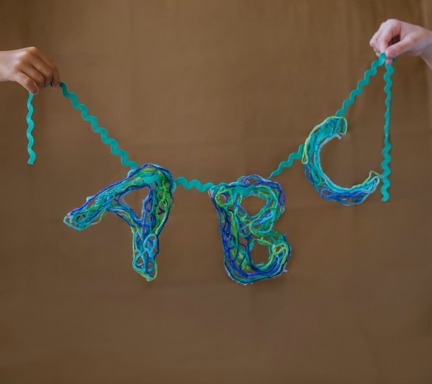

Questions:

1. What is a class?
   1. What are some predefined classes that we have used in class that Java provides?
2. What is an object?
   1. What does a class define about an object?



1. Using the Scanner class, can you tell me the steps to make an object? (Do we need to import anything?)
2. Go into Eclipse and using the Math class, try to make an object like the Scanner class
   1. What happens? *Why*?



* 1. What is a constructor and what is it used for?

1. What is a static method?
   1. Can you show me how we call pow() and random() from the Math class?
      1. What do pow() and random() do?
      2. What are other things that the Math class provides?
   2. Complete the following table and feel free to use for your Tech Doc

|  | Math Class | String class |
| --- | --- | --- |
| How to access class methods? |  |  |
| Do we need an instance to access methods? |  |  |

1. What is method overloading?
   1. Can you give me some examples in the Math class where this is done? (Hint, type “Math.” in Eclipse to view API)
2. What is a string?
   1. Check out the string below:



* + 1. In Eclipse, using charAt() method, how do I return the first char? How about the last? (**Hint**: Do NOT hardcode for the last char)
       1. Store this returned value in a variable called firstInitial. What data type do we need to use? Why?

1. Complete the following table:

|  | String | char |
| --- | --- | --- |
| What is it? |  |  |
| Single/double quotations? |  |  |
| Example of initialization |  |  |
| How to read it from keyboard? |  |  |